A REPORT
on
Hospital Training - II
Submitted in Partial Fulfillment of the requirements For the Degree of
Bachelor of Pharmacy
By
Neha Verma B.Pharm. IV Year, VII Semester
Roll No.:2010180500052
Ambekeshwar Institute of Pharmaceutical Sciences (Lucknow)



Under the Supervision of
SUPERVISOR
Prof (Dr.) Savita Upadhyay Director (Pharmacy)
AIPS, Lucknow

CO-SUPERVISOR
Mr. Devendra Kumar Mishra
Assistant Professor AIPS, Lucknow

to the
Faculty of Pharmacy
Dr. A.P.J. Abdul Kalam Technical University, Lucknow 2023-2024



CERTIFICATE OF COMPILATION

This is to certify that this project report entitled “Hospital Training - II” submitted to Ambekeshwar Institute of Pharmaceutical Sciences, Lucknow, is a bonafide record of work done by Neha Verma (Roll No.:2010180500052) during the period of his/her study in Bachelor of Pharmacy in the academic year 2023-2024 in the Seventh semester of Fourth Year.

SUPERVISOR
Prof (Dr.) Savita Upadhyay Director (Pharmacy)
AIPS, Lucknow
CO-SUPERVISOR
Mr. Devendra Kumar Mishra Assistant Professor
AIPS, Lucknow

EXTERNAL EXAMINER

DATE: ……………………

COPYRIGHT

Declaration by the Candidate

I hereby declare that the Ambekeshwar Institute of Pharmaceutical Sciences, Lucknow shall have the rights to preserve, use and disseminate the report in print or electronic format for academic/ research purpose.

Place: Lucknow Neha Verma
Date: Roll No.:2010180500052

DECLARATION BY THE CANDIDATE

This is to certify that the work presented in the report entitled “Hospital Training - II” has been carried out by me for the partial fulfillment of degree of ‘Bachelor of Pharmacy’ under the supervision of Prof (Dr.) Savita Upadhyay and Co-supervision of Mr. Devendra Kumar Mishra of Ambekeshwar Institute of Pharmaceutical Sciences, Lucknow.
The report embodies results of the original work and studies carried out by me and the contents of the report have not formed the basis for the award of any degree/ diploma by any other University or Institution.
I also confirm that all the material which I have borrowed from other sources and incorporated in this report is duly acknowledged.

Place: Lucknow Neha Verma
Date: Roll No.:2010180500052

CERTIFICATE BY THE CO-SUPERVISOR

This is to certify that the work presented in the report entitled “Hospital Training - II” submitted by Neha Verma (Roll No.:2010180500052) for the degree of ‘Bachelor of Pharmacy’ has been carried out in the Ambekeshwar Institute of Pharmaceutical Sciences, Lucknow under my guidance.

Place: Lucknow
Date:
Mr. Devendra Kumar Mishra
Assistant Professor AIPS, Lucknow

CERTIFICATE BY THE SUPERVISOR

This is to certify that the work presented in the report entitled “Hospital Training - II” submitted by Neha Verma (Roll No.:2010180500052) for the degree of ‘Bachelor of Pharmacy’ has been carried out in the Ambekeshwar Institute of Pharmaceutical Sciences, Lucknow under the co-supervision of Mr. Devendra Kumar Mishra, Assistant Professor, Ambekeshwar Institute of Pharmaceutical Sciences, Lucknow.

Place: Lucknow
Date:
Prof (Dr.) Savita Upadhyay
Director (Pharmacy) AIPS, Lucknow

Acknowledgement

First of all, I would like to thank my god, helping me starting from the beginning to the end of my training period.
I have supreme gratitude to Ambekeshwar Institute of Pharmaceutical Sciences for providing such kind of opportunity for students to broaden their perception on how the real world in the field of medical and pharmacy world as well as organizing the whole training program and its effort to make sure that the whole internship program to achieve its desired goals.
I would also like to express my special thanks to MR. RAJESH JHA, chief pharmacist of
RAM SAGAR MISHRA 100 BEDDED COMBINED HOSPITAL, for giving me chance
to spend my training in their hospital.
I extend my gratitude thank to all the staffs, doctors, nurses and also my family and friends for always their guidance and support.

Place: Lucknow
Date:
Neha Verma

List of Tables
Table no.1–Examples of various drugs 10

List of Figures
Figure no.1-Hospital 1
Figure no.2-Department of pharmacy 3
Figure no.3-First aid… 4
Figure no.4-Dressing… 7
Figure no.5-Pathology 10
Figure no.6-Pharmacy 11
Figure no. 7-Route of administration 14
Figure no. 8-Operation theatre 15
Figure no. 9-Emergency 16

List of Abbreviations

Abbreviation | Name
CPR | Cardio pulmonary resuscitation
OPD | Outpatient department
SC | Subcutaneous
IM | Intramuscular
ID | Intradermal
IV | Intramuscular
IT | Intrathecal
IP | Intraparitoneal

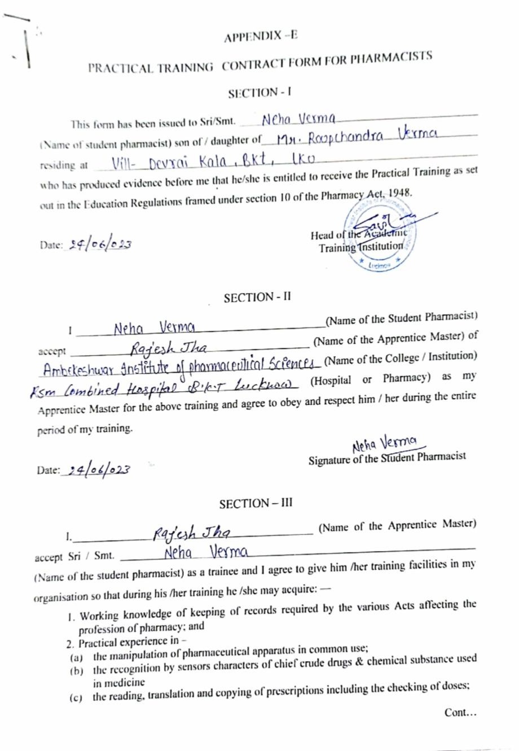

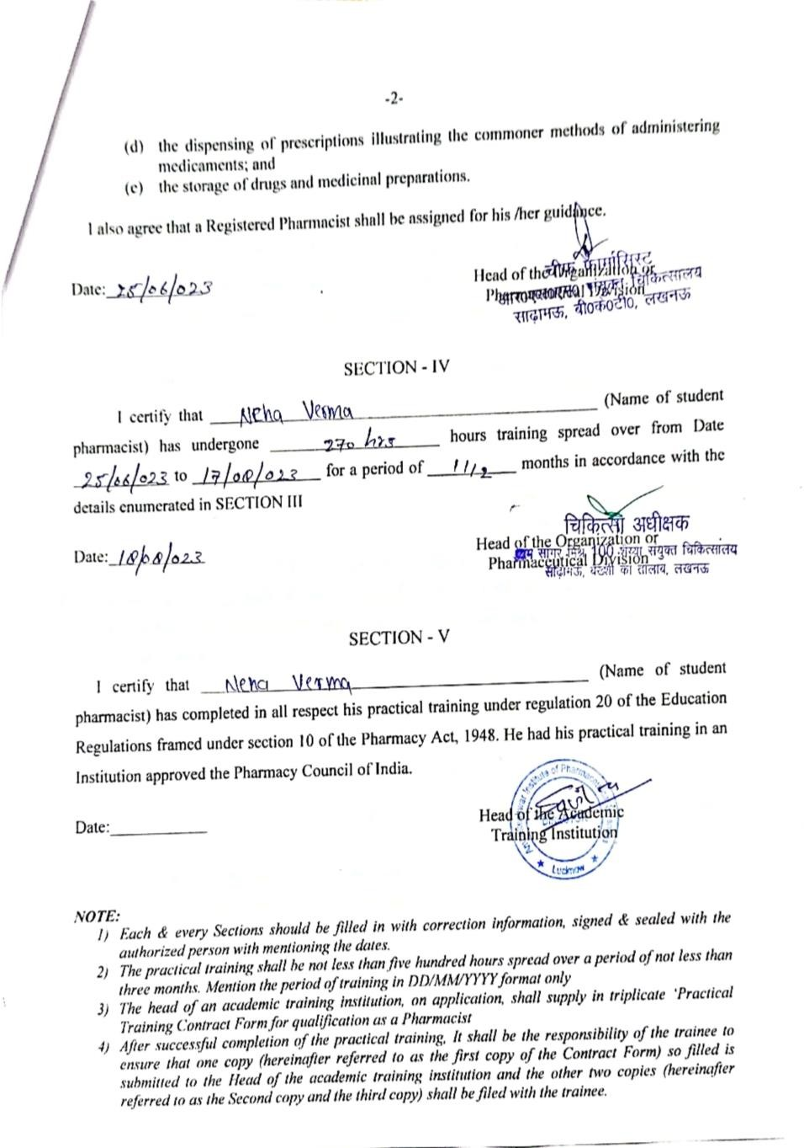

CONTENTS

S. No | Particulars | Page No.
1. | Certificate of Compilation | ii
2. | Copyright | iii
3. | Declaration by the Candidate | iv
4. | Certificate by the Co-Supervisor | v
5. | Certificate by the Supervisor | vi
6. | Acknowledgement | vii
7. | List of Tables | viii
8. | List of Figures | ix
9. | List of Abbreviation | x
10. | Practical Training Contract Form for Pharmacists | xi-xii
11. | Introduction | 1
12. | Hospital Profile | 2
13. | Training Imparted | 3-17
14. | Observation | 18
15. | Result and Discussion | 19
16. | Conclusion | 20
17. | Bibliography | 21

Introduction

INTRODUCTION
A hospital is a healthcare institution providing patient treatment with specialized health science and auxiliary healthcare staff and medical equipment. The best-known type of hospital is the general hospital, which typically has an emergency department to treat urgent health problems ranging from fire and accident victims to a sudden illness. A district hospital typically is the major health care facility in its region, with many beds for intensive care and additional beds for patients who need long-term care.
Specialized hospitals include trauma centers, rehabilitation hospitals, children's hospitals, seniors' (geriatric) hospitals, and hospitals for dealing with specific medical needs such as psychiatric treatment (see psychiatric hospital) and certain disease categories. Specialized hospitals can help reduce health care costs compared to general hospitals.
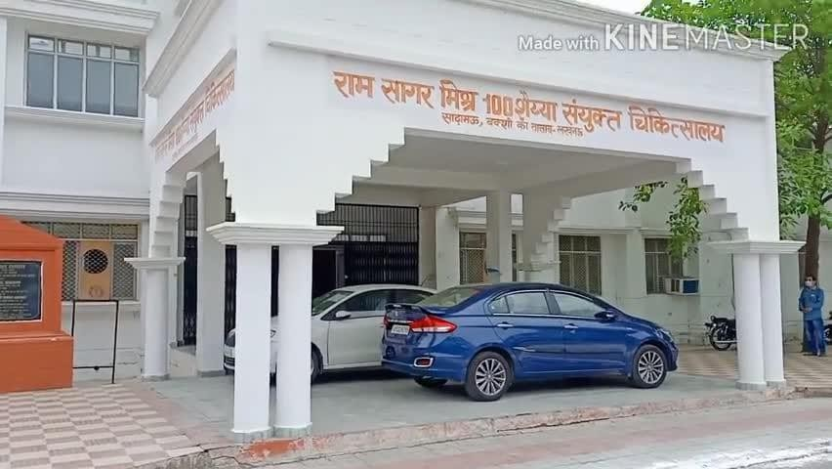

Figure no.1-HOSPITAL

Hospital Profile

HOSPITAL PROFILE
Hospitals are largely staffed by professional physicians, surgeons, nurses, and allied health practitioners, whereas in the past, this work was usually performed by the members of founding religious orders or by volunteers. Some patients go to a hospital just for diagnosis, treatment, or therapy and then leave ("outpatients") without staying overnight; while others are "admitted" and stay overnight or for several days or weeks or months ("inpatients"). Hospitals are usually distinguished from other types of medical facilities by their ability to admit and care for inpatients whilst the others, which are smaller, are often described as clinics.
A hospital may also have a department of nursing, headed by a chief nursing officer or director of nursing. This department is responsible for the administration of professional nursing practice, research, and policy for the hospital.
Many units have both a nursing and a medical director that serve as administrators for their respective disciplines within that unit. For example, within an intensive care nursery, a medical director is responsible for physicians and medical care, while the nursing manager is responsible for all the nurses and nursing care.
Support units may include a medical records department, release of information department, technical support, clinical engineering, facilities management, plant operations, dining services, and security departments.

Function of Hospital
Below mentioned are some of the functions of hospital/hospital use: -
- Medical hospital includes the treatment and management of patients by a team of doctors.
- Patient Support provides nursing, nutritional diagnostic, counseling, pharmacy, and medical supplies, all of which are directly related to patient care.
- Administrative responsibilities include carrying out the hospital's guidelines and directives regulating the release of support services in the areas of finance, staff, housekeeping, materials and property, laundry, protection, transportation, engineering, and board as well as several other maintenances.
- The hospital's financial activities must be planned, guided, and coordinated
- Patients in a hospital as well as the employees working there.
- Prepare a job and financial plan for services and initiatives, as well as funding projections.

Different Departments in Hospital
There are number of parts in a hospital. This considerable number of departments is responsible fortreating the patients of their diseases.
The various departments of hospitals covered in the hospital training are:
- Dispensary
- In-Patient Department
- Children Ward
- Emergency (Trauma center)
- Record Room
- Injection Room
- Waste Management
- Rabies Vaccination
- Ortho wards
- Trauma Centre
- Blood bank
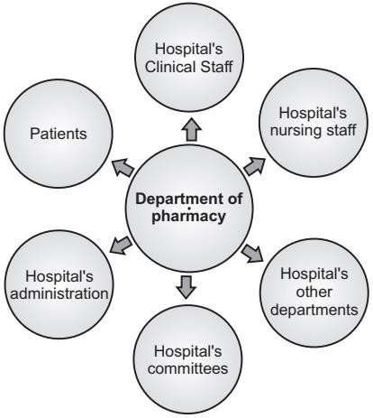

Figure no.2–DEPARTMENT OF PHARMACY

FIRST AID
First aid is the assistance given to any person suffering a sudden illness or injury, with care provided to preserve life, prevent the condition from worsening, and/or promote recovery.
It includes initial intervention in a serious condition prior to professional medical help being available, such as performing CPR while awaiting an ambulance, as well as the complete treatment of minor conditions, such as applying a plaster to a cut.
First aid is performed by the layperson, with many people trained in providing basic levels of first aid, andothers willing to do so from acquired knowledge. Mental health first aid is an extension of the concept of first aid to cover mental health.
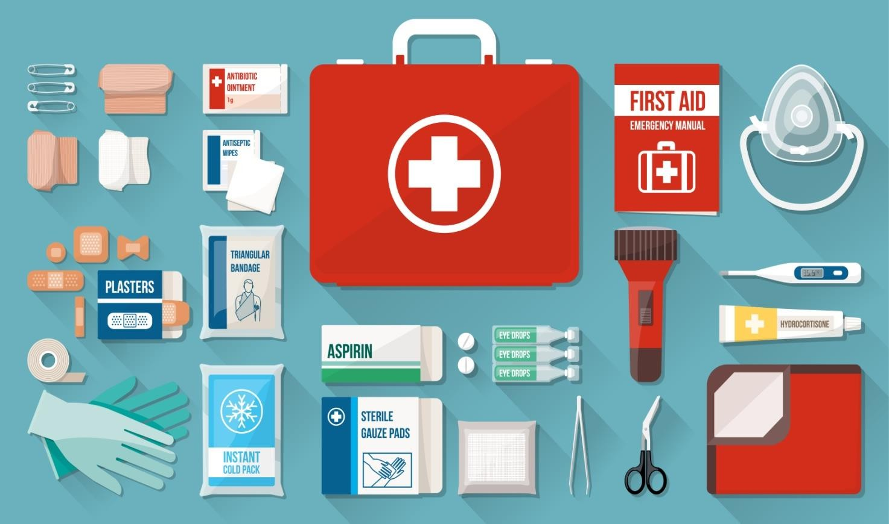

Figure no.3-FIRST AID

Types of first aid

- Emergency First Aid
This includes the content for Basic First Aid involving life threatening injuries. Focus is on Airway, Breathing and Circulatory emergencies and prevention of such. This course comes with CPR A (Adult skills) or CPR C (Adult, Child, and Infant skills).

- Standard First Aid
Required by most employers, preferred by parents. All content of the Emergency first aid is covered as well as wound care, head neck and spine injuries and more. This course comes with CPRA (Adult skills) or CPR C (Adult, child, and Infant skills).

- Child Care First Aid
This meant for Day home/Day care Providers. Covers the content for Standard FirstAid plus additional content for Childhood Illnesses and Safety. Comes with a level-B CPR (Adult, Child, and Infant skills).

- Babysitter Course
For age of range 11-15. Designed for pre-teens and teens. Include basic first aid and safety skills. Focus of this course is preventing and responding to emergencies should they occur while babysitting. This course also offers youth the training to promote themselves as a babysitter to prospective parents.

- Home Alone Course
For age range 9-12. Designed for kids staying home for a brief period. Focus is on safety and responding to emergencies.

- Psychological First Aid
Psychological First Aid is a resiliency building wellness program that equips individuals in supporting themselves and others to cope with the effects of stress, loss, trauma, and grief.

ABCDE method

Airway (clearing airways)
If the patient responds in a normal voice, then the airway is patent. Airway obstruction can be partial or complete. Signs of a partially obstructed airway include a changed voice, noisy breathing (e.g., stridor), and an increased breathing effort. With a completely obstructed airway, there is no respiration despite great effort (i.e., paradox respiration, or "see-saw" sign). A reduced level of consciousness is a common cause of airway obstruction, partial or complete. A common sign of partial airway obstruction in the unconscious state is snoring.

Untreated airway obstruction can rapidly lead to cardiac arrest. All health care professionals, regardless of the setting, can assess the airway as described and use a head-tilt and chin-lift maneuver to open the airway. With the proper equipment, suction of the airways to remove obstructions, for example, blood or vomit, is recommended. If possible, foreign bodies causing airway obstruction should be removed. In the event of a complete airway obstruction, treatment should be given according to current guidelines.

Breathing (ensuring respiration)
In all settings, it is possible to determine the respiratory rate, inspect movements of the thoracic wall for symmetry and use of auxiliary respiratory muscles, and percuss the chest for unilateral dullness or resonance. Cyanosis, distended neck veins, and lateralization of the trachea can be identified. If a stethoscope is available, lung auscultation should be performed and, if possible, a pulse oximeter should be applied. Tension pneumothorax must be relieved immediately by inserting a cannula where the second intercostal space crosses the midclavicular line (needle thoracocentesis). Bronchospasm should be treated with inhalations. If breathing is insufficient, assisted ventilation must be performed by giving rescue breaths with or without a barrier device. Trained personnel should use a bag mask if available.

Circulation (internal bleeding)
The capillary refill time and pulse rate can be assessed in any setting. Inspection of the skin gives clues to circulatory problems. Color changes, sweating, and a decreased level of consciousness are signs of decreased perfusion. If a stethoscope is available, heart auscultation should be performed. Electrocardiography monitoring and blood pressure measurements should also be performed as soon as possible. Hypotension is an important adverse clinical sign. The effects of hypovolemia can be alleviated by placing the patient in the supine position and elevating the patient's legs. An intravenous access should be obtained as soon as possible and saline should be infused.

Disability (neurological condition)
The level of consciousness can be rapidly assessed using the AVPU method, where the patient is graded as alert (A), voice responsive (V), pain responsive (P), or unresponsive (U). Alternatively, the Glasgow Coma Score can be used.16 Limb movements should be inspected

to evaluate potential signs of lateralization. The best immediate treatment for patients with a primary cerebral condition is stabilization of the airway, breathing, and circulation. In particular, when the patient is only pain responsive or unresponsive, airway patency must be ensured, by placing the patient in the recovery position, and summoning personnel qualified to secure the airway. Ultimately, intubation may be required. Pupillary light reflexes should be evaluated and blood glucose measured. A decreased level of consciousness due to low blood glucose can be corrected quickly with oral or infused glucose.

Exposure (overall examination, environment)
Signs of trauma, bleeding, skin reactions (rashes), needle marks, etc., must be observed. Bearing the dignity of the patient in mind, clothing should be removed to allow a thorough physical examination to be performed. Body temperature can be estimated by feeling the skin or using a thermometer when available.

DRESSING
A dressing is a sterile pad or compress applied to a wound to promote healing and protect the wound from further harm. A dressing is designed to be in direct contact with the wound, as distinguished from a bandage, which is most often used to hold a dressing in place. Many modern dressings are self- adhesive.
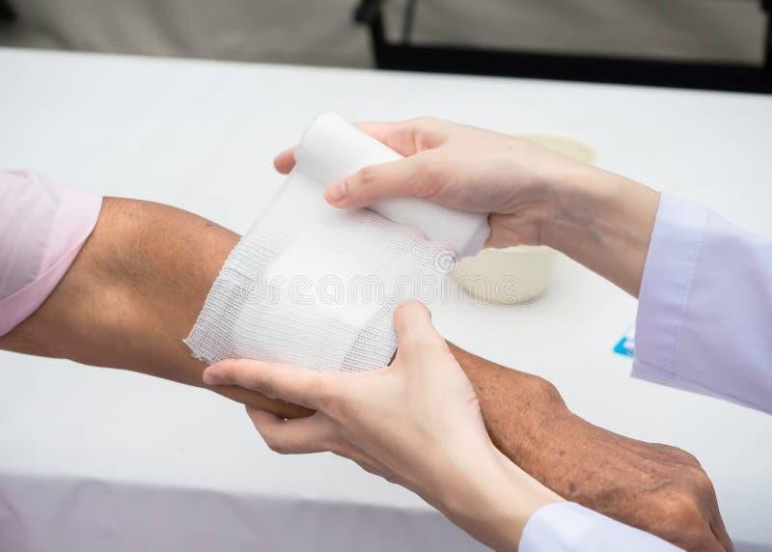
Figure no.4–DRESSING

Key purposes of a dressing are:
- Stop bleeding – to help to seal the wound to expedite the clotting process;
- Protection from infection – to defend the wound against germs and mechanical damage.
- Absorb exudates – to soak up blood, plasma, and other fluids exuded from the wound, containing it/them in one place and preventing maceration;
- Ease pain – either by a medicated analgesic effect, compression or simply preventing pain from further trauma;
- Debride the wound – to remove slough and foreign objects from the wound to expedite healing

ARTIFICIAL RESPIRATION
In Artificial respiration, breathing induced by some manipulative technique when natural respiration has ceased or is faltering. Such techniques, if applied quickly and properly, can prevent some deaths from drowning, choking, strangulation, suffocation, carbon monoxide poisoning, and electric shock. Resuscitation by inducing artificial respiration consists chiefly of two actions:
- Establishing and maintaining an open air passage from the upper respiratory tract (mouth, throat, and pharynx) to the lungs
- Exchanging air and carbon dioxide in the terminal air sacs of the lungs while the heart is still functioning.

PATHOLOGY
Pathology is a branch of medical science primarily concerning the cause, origin, and nature of disease. It involves the examination of tissues, organs, bodily fluids, and autopsies to study and diagnose disease.
Here are common tests performed during the hospital training in hospital
- Widal test
- Pregnancy test
- Glucose test
- Blood group test
- Urine test

Widal Test
Salmonella typhi and Salmonella paratyphoid A, B and C cause enteric fever (typhoid and paratyphoid) in human. Laboratory diagnosis of enteric fever includes Blood culture, Stool Culture and Serological test. Widal test is a common agglutination test employed in the serological diagnosis of enteric fever. Thistest by Georges Ferdinand Widal in 1896 and helps to detect presence of salmonella antibodies in a patient’s serum.

Glucose test
Both low blood sugar (hypoglycemia) and high blood sugar (hyperglycemia) are of concern for patientswho take insulin. It is important, therefore, to carefully monitor blood glucose levels. In general, patients with type 1 diabetes need to take readings four or more times a day. Patients should aim for the following measurements:
Pre-meal glucose levels of 70 - 130 mg/Dl
Post-meal glucose levels of less than 180 mg/dL. Different goals may for specific individuals, including pregnant women, old and incredibly young people, and those with accompanying serious medical conditions.

Finger-Prick Test
A typical blood sugar test includes the following:
- A drop of blood by pricking the finger.
- The blood is then applied to a chemically treated strip.
- Monitors read and provide results.
Home monitors are less accurate than laboratory monitors and do not meet the standards of the American Diabetes Association. However, they are usually accurate enough to indicate when blood sugar is too low. To monitor the amount of glucose within the blood a person with diabetes should evaluate their blood regularly.
The procedure is quite simple and can often be done at home. simple procedures may improve accuracy:
- Evaluating the meter once a month.
- Recalibrating it whenever a new packet of strips is used.
- Using fresh strips; outdated strips may not provide accurate results.
- Keeping the meter clean.
- Periodically comparing the meter results with the results from a laboratory.

Blood group test
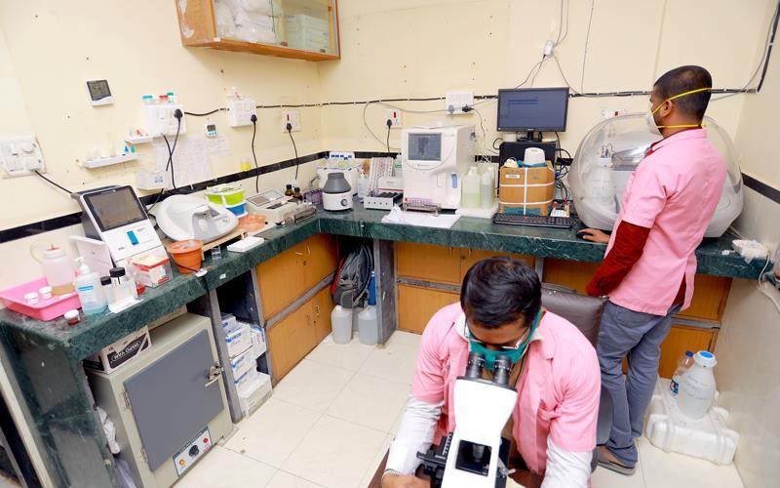
A test kit can be used to evaluate blood type. It involves pricking finger and placing a drop of blood on a card that will react to a serum on the card that contains antibodies. Now we will be given the opportunity to evaluate blood type using this technique.
Figure no.5-PATHOLOGY

DISPENSARY
A dispensary can be defined as themain area where the dispensing of the drugs takes place. It is present for the OPD patients. The various drugs are being distributed to the patients here based on their prescription written by the doctors. The dispensary in the district hospital consists of various pharmacists who are present to hand out the medicines to the patients. The distribution of the drugs in the district hospital is for free.

The various drugs which are being distributed are: -
Table no 1 – Examples various drugs

S. NO. | DRUGS
1 | Alusil-C – Antacid chewable tablets
2 | Paracetamol tablets and suspension
3 | Calcium tablets
4 | Chlorpheniramine Maleate tablets
5 | B-Complex tablets
6 | Ciprofloxacin Capsules
7 | Ciprofloxacin Capsules
8 | Doxycyclin capsules
9 | Doxycyclin capsules
10 | Metronidazole
The drug distribution in the dispensary takes place through windows. These windows are of: -
- Women
- Men
- Elderly i.e., above age 60
- Staff members
The people are required to stand according to these lines only to get the prescribed medicines. The pharmacist also has the job to explain the time of administration and the amount of dose to be given to the patient.

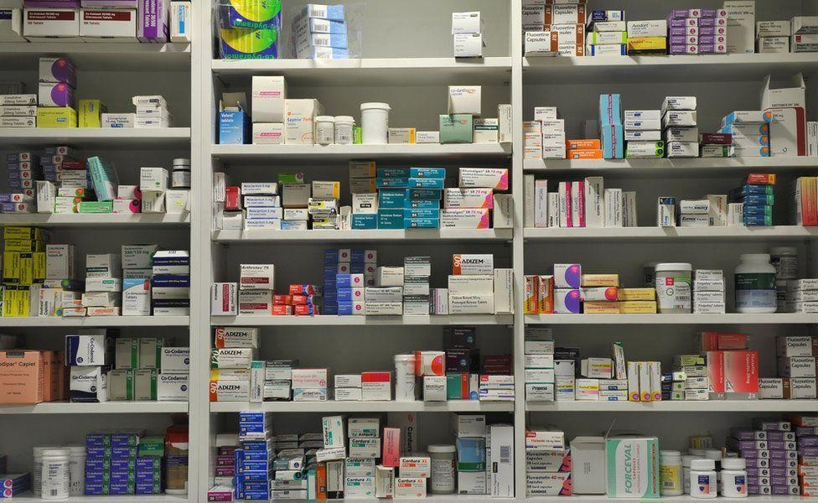

Figure no.6-PHARMACY

Different Routes of administration
- Oral route
- Sublingual/ Buccal route
- Rectal route
- Topical route
- Transdermal route
- Inhalational route/ pulmonary route
- Injection route

Oral route
This is the most frequently used route for drug administration. When possible, it is the first choice for the administration of drugs since it is both convenient and economical. Drugs administered orally are placed in the mouth and swallowed.
Most drugs that are given orally are absorbed into the circulation from the gastrointestinal tract very efficiently within the limits of the physicochemical properties of the drug concerned. Certain drugs are taken orally for their local effects within the bowel e.g., antacids

for heartburn and ezetimibe for the reduction of cholesterol absorption.
Oral agents must be able to withstand the acidic environment of the stomach and must permeate the gut lining before entering the bloodstream. The most popular oral dosage forms are tablets, capsules, suspensions, solutions, and emulsions.

Sublingual/ Buccal route
In this route of administration, the drug is placed under the tongue (sublingual route) or between gums and inner lining of the cheek (buccal route). In both cases, the drug is allowed to dissolve, avoiding swallowing as far as possible. The drug is rapidly absorbed through the mucosa into circulation, thereby by passing the portal circulation and, thus, the first-pass metabolism in the liver. Sublingual and buccal routes are of value when the medication concerned is destroyed or partially inactivated in the stomach if swallowed and when a more rapid action is required. These routes however are not suitable for bitter preparations.

Rectal route
Medications are sometimes ordered to be administered by rectal route. The rectal mucosa can absorb soluble drugs into the circulation. Rectal medication may be in suppository form or in liquid form to be administered as a retention enema.
Unlike the oral route, drugs with irritant or unpalatable nature can be administered through the rectum. Rectal route can also be preferred when the patient has persistent vomiting or is unable to swallow. Also, this route can be used for systemic drug administration in addition to the local administration.

Topical route
Drugs are applied topically, that is to the skin or mucous membrane of the eye, ear, nose, mouth, vagina,etc., for local action. This route provides a high local concentration of the drug without affecting the general circulation. However, drugs that are absorbed into the circulation after local administration may then have systemic effects. Drugs for topical applications are available as creams, ointments, liniments,and drops.

Transdermal route
The transdermal route is commonly referred to as “the patch” because the medication is contained in a patch that is absorbed through the skin. Drugs administered through this route

must be highly lipophilic. Absorption via this route is slow but conducive to producing long- lasting effects. Special slow-release matrices in transdermal patches can maintain steady drug concentrations that approach those of constant IV infusion. Transdermal patches also provide less absorption problems in the gastrointestinal tract that are commonly experienced by patients who take oral medication.

Inhalational route/ pulmonary route
Drug delivery by inhalation is a common route, both for local and for systemic actions. This delivery route is particularly useful for the direct treatment of asthmatic problems, using both powder aerosols (e.g., salmeterol xinafoate) and pressurized metered-dose aerosols containing the drug in liquefied inert propellant (e.g., salbutamol sulphate inhaler).

Injection routes
This is the second commonest route of drug administration. They involve introducing the drug in form of solution or suspension into the body at various sites and to varying depths using syringe and needle. Thus, administration involves risk of infection, pain, and local irritation.
They are following types:
  - SC - Subcutaneous
  - IM - Intramuscular
  - ID - Intradermal
  - IV - Intravenous
  - IT - Intrathecal
  - IP - Intraperitoneal

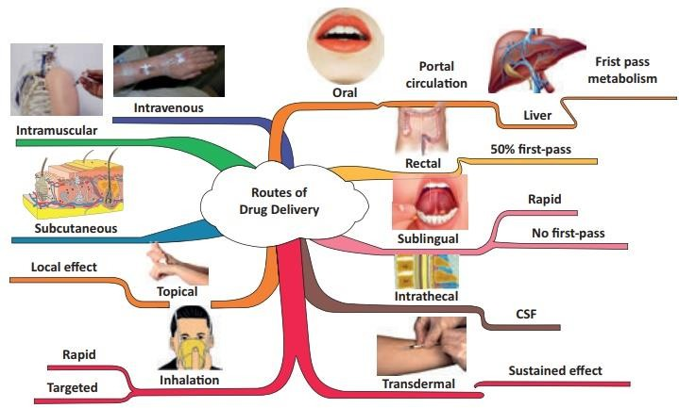

Figure no.7–ROUTE OF ADMINISTRATION

OPERATION THEATRE
The surgical suite consists of two operating rooms. The Hospital has a team of anesthetists, surgeons, trained nurses, and staff working in operation theatre. Every day the operating team is performing surgery,very often also emergency operation due to late delivery of patients.
Theatre Department to cater for the following discipline of surgery:
- General Surgery ENT
- Ear, Nose, and Throat Surgery
- Orthopedics Surgery
- Obstetrics & Gynecology Surgery
- Plastic Surgery

Surgical Ward
The surgical ward is an in-patient department which consists of those patients who are: -
- Severely injured
- Undergoing a surgery wounded
- Male Surgical ward – It consists of all the male patients
- Female Surgical Ward – It consists of all the female patient

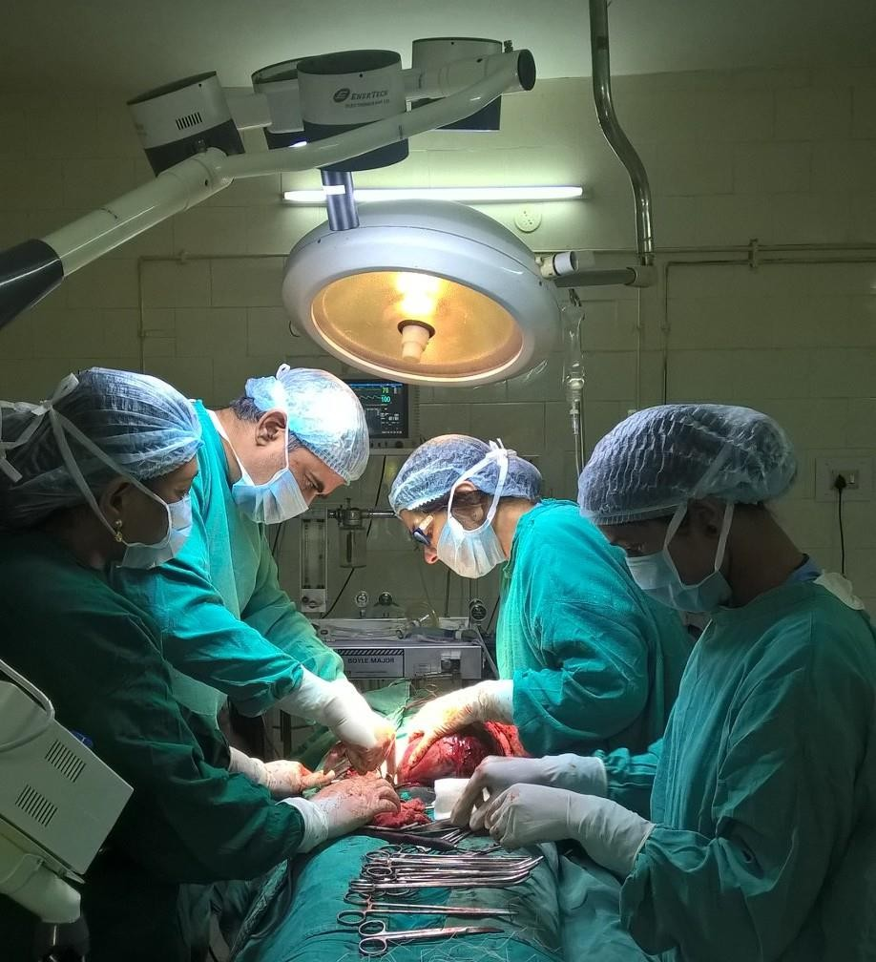
Figure no.8–OPERATION THEATRE

EMERGENCY ROOM
An Emergency Room treats many common conditions ranging from minor, non-life- threatening injuries to heart attacks and strokes. The training for Emergency Medicine differs from Trauma becauseit typically encompasses a broader spectrum of emergency conditions.
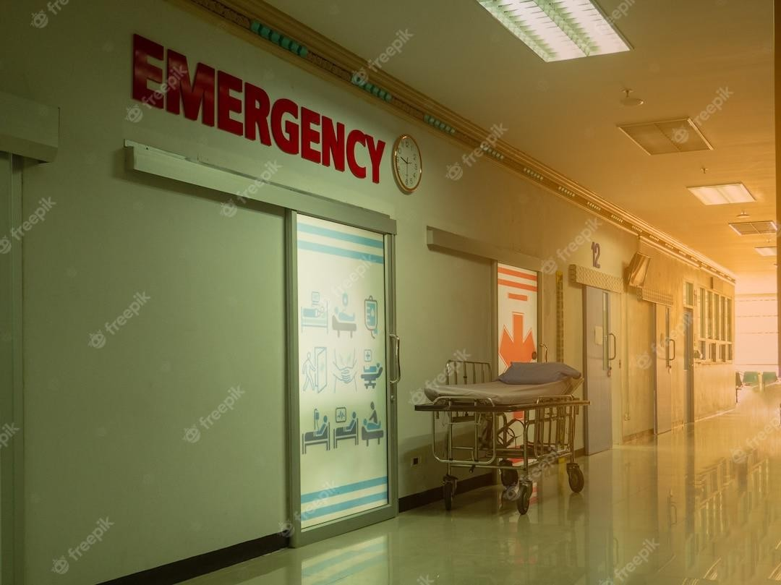
Figure no.9-EMERGENCY

Physicians and surgeons in emergency medicine see patients with the following types of injuries orconditions:
  - Broken bones
  - Chest pains
  - Loss of consciousness
  - Minor burns
  - Minor lacerations requiring stitches
  - Severe abdominal pain/ vomiting/ diarrhea
  - Sprains
  - Signs of a heart attack
  - Signs of a stroke

Trauma Center and Emergency
Trauma care teams treat patients that have critical injuries threatening life or limbs. These severelyinjured patients often require multi-disciplinary, comprehensive emergency medical services. Trauma surgeons have advanced training in procedures of a critical and invasive nature. There are certain criteria to follow and triage guidelines that identify the more seriously injured patients. Trauma units have the resources and expertise to handle more extreme cases where immediate survival is a concern.
Physicians and surgeons at Penn's Level 1 Trauma Center see patients with the following types of injuries:
- Injuries related to traumatic car crashes
- Traumatic brain injuries
- Blunt force trauma
- Gunshot and stab wounds

OBSERVATION

During the period of hospital training, I observed that the hospital is a crucial part of the health system. It provides outpatient, inpatient and emergency medical care for sick and injured people. Here the outpatient department is for a consultation. An emergency room provides facilities that are used in urgent situation.
It is also important for trained doctors, nurses and other health care professionals. Hospital departments provide a variety of services. Some are concerned of the diagnosis of the disease, like pathology and imaging departments. They also provide medical, surgical and other specialized treatment. There is also a specific department which looks after the nutrition, rehabilitation and other needs of patients admitted to the hospital. Here under the guidance of hospital professional, I came to learn about how to dispense medicines to the patient, how to inject injections to them, how to handle trauma and emergency cases.

RESULT AND DISCUSSION

The hospital training helps us to understand the requirement of average hospital facilities that provide easy and effective management of hospital. Mainly it is managed by the department of nursing and medical administrators with their respective discipline. The hospital training provides the opportunity to be familiar with the hospital environment and helps us to understand us making a difference between pharmacist with others. During the training period, I used to learn the basic first aid technique, dressing procedure, to inject parenteral and also to dispense medication. I also learned about the examination of diagnostic report that helps to understand pathological condition of patient. Here I also get some information about the radiological department and also learn about the dispensing procedure of the medication. The dispensing of medication also includes the understanding of parts and abbreviation used in prescription. Here I also learned about the emergency situation and how these situations are handled.

CONCLUSION

The hospital training provides a brief introduction of the structure and function of hospital system. it helps to understand how hospital operated by different department and provide basic care to the patients. The various department required for management of hospital are inpatient department, dispensary, emergency room, record room, injection room, vaccination pathology, blood bank etc. The basic first aid is a primary care for patients that prevent lives and minimize threat of death. The pathology and radiology lead to the identification of the disease that helps in the treatment of disease. The facilities provide to patient in district hospital is in a very affordable range i.e. only one rupee per patients. the conclusion drawn from the training is that it helps to understand the remarkable role of district hospital in health care society that used to save peoples life and it also shows us their good deed towards humankind and to their service.

BIBLIOGRAPHY

- https://en.wikipedia.org/wiki/Hospital
- https://en.wikipedia.org/wiki/First_aid
- https://www.news-medical.net/health/What-is-Pathology.aspx
- https://www.ncbi.nlm.nih.gov/books/NBK519065/
- https://www.ncbi.nlm.nih.gov/books/NBK568677/
- https://www.irishospital.co.in/operation-theatres/
- https://www.sciencedirect.com/topics/nursing-and-health-professions/emergency-ward

